Experiment – 8

AIM
To study and design a 4-bit BCD adder.

PLATFORM/TOOL USED
- Simulator: https://circuitverse.org/simulator

THEORY
The digital systems handle the decimal number in the form of binary coded decimal numbers (BCD). A BCD Adder Circuit that adds two BCD digits and produces a sum digit also in BCD. BCD numbers use 10 digits, 0 to 9 which are represented in the binary form 0 0 0 0 to 1 0 0 1, i.e., each BCD digit is represented as a 4-bit binary number. When we write BCD number say 526, it can be represented as
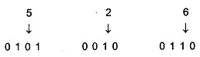

Suppose we have two 4-bit numbers A and B. The value of A and B can vary from 0(0000 in binary) to 9(1001 in binary) because we are considering decimal numbers.
The output will vary from 0 to 18 if we are not considering the carry from the previous sum. But if we are considering the carry, then the maximum value of output will be 19 (i.e., 9+9+1 = 19).

The BCD addition procedure as follows:
- Add two BCD numbers using ordinary binary addition.
- If four-bit sum is equal to or less than 9, no correction is needed. The sum is in proper BCD form.
- If the four-bit sum is greater than 9 or if a carry is generated from the four-bit sum, the sum is invalid.
- To correct the invalid sum, add 01102 to the four-bit sum. If a carry results from this addition, add it to the next higher-order BCD digit.

Thus, to implement BCD Adder Circuit we require:
- 4-bit binary adder for initial addition
- Logic circuit to detect sum greater than 9 and
- One more 4-bit adder to add 01102 in the sum if sum is greater than 9 or carry is 1.

The logic circuit to detect sum greater than 9 can be determined by simplifying the Boolean expression of given BCD Adder Truth Table.
The Logic Diagram and Truth Table of a 4-bit BCD Adder is given in the table.

Block Diagram for BCD Adder
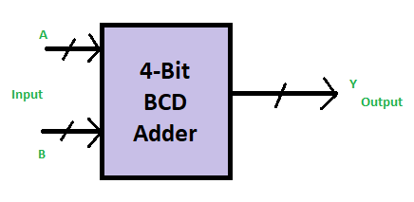

Truth Table for BCD ADDER
Decimal | Binary Sum |  |  |  |  | BCD Sum
Decimal | C’ | S₃’ | S₂’ | S₁’ | S₀’ | C | S₃ | S₂ | S₁ | S₀
0 | 0 | 0 | 0 | 0 | 0 | 0 | 0 | 0 | 0 | 0
1 | 0 | 0 | 0 | 0 | 1 | 0 | 0 | 0 | 0 | 1
2 | 0 | 0 | 0 | 1 | 0 | 0 | 0 | 0 | 1 | 0
3 | 0 | 0 | 0 | 1 | 1 | 0 | 0 | 0 | 1 | 1
4 | 0 | 0 | 1 | 0 | 0 | 0 | 0 | 1 | 0 | 0
5 | 0 | 0 | 1 | 0 | 1 | 0 | 0 | 1 | 0 | 1
6 | 0 | 0 | 1 | 1 | 0 | 0 | 0 | 1 | 1 | 0
7 | 0 | 0 | 1 | 1 | 1 | 0 | 0 | 1 | 1 | 1
8 | 0 | 1 | 0 | 0 | 0 | 0 | 1 | 0 | 0 | 0
9 | 0 | 1 | 0 | 0 | 1 | 0 | 1 | 0 | 0 | 1
10 | 0 | 1 | 0 | 1 | 0 | 1 | 0 | 0 | 0 | 0
11 | 0 | 1 | 0 | 1 | 1 | 1 | 0 | 0 | 0 | 1
12 | 0 | 1 | 1 | 0 | 0 | 1 | 0 | 0 | 1 | 0
13 | 0 | 1 | 1 | 0 | 1 | 1 | 0 | 0 | 1 | 1
14 | 0 | 1 | 1 | 1 | 0 | 1 | 0 | 1 | 0 | 0
15 | 0 | 1 | 1 | 1 | 1 | 1 | 0 | 1 | 0 | 1
16 | 1 | 0 | 0 | 0 | 0 | 1 | 0 | 1 | 1 | 0
17 | 1 | 0 | 0 | 0 | 1 | 1 | 0 | 1 | 1 | 1
18 | 1 | 0 | 0 | 1 | 0 | 1 | 1 | 0 | 0 | 0
19 | 1 | 0 | 0 | 1 | 1 | 1 | 1 | 0 | 0 | 1

The K-map for the expression to check whether the BCD sum values greater than 9, up to decimal number 15 is given below:
K-Map for BCD Adder
For Y
I₁I₀  I₃I₂ | 00 | 01 | 11 | 10
00 | 0 | 0 | 0 | 0
01 | 0 | 0 | 0 | 0
11 | 1 | 1 | 1 | 1
10 | 0 | 0 | 1 | 1
$$Y = S_{3}S_{2}+S_{3}S_{1}$$
For Binary sum values greater than 15, the carry bit is 1 (high), which updates the expression obtained to –
$$\boxed{Y = {C^{'}+S}_{3}S_{2}+S_{3}S_{1}}$$

The Boolean Expressions for the conditions detecting that the Binary Sum is greater than 9 to convert it to BCD by considering the carry bit as 1 in BCD representation for the ten’s place BCD digit.

Boolean Expressions for BCD Adder
$$\boxed{S_{3}S_{1}=1d} (Condition 10 and 11)$$
$$\boxed{S_{3}S_{2}=1} (Condition for 12-15)$$
$$\boxed{C^{'}=1} (Condition for 16-19)$$

Logic for the checking the INVALID SUM (greater than 9)
$$\boxed{{{Y= C}^{'}+S}_{3}S_{2}+S_{3}S_{1}}$$

Logic Diagram for BCD Adder
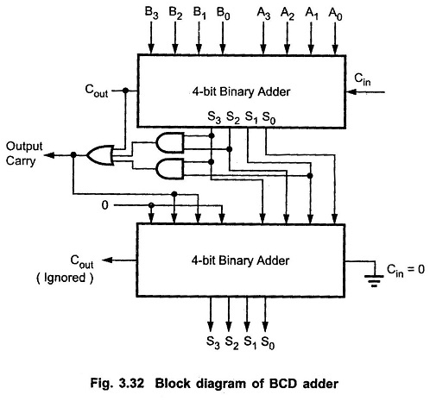v

SIMULATED OUTPUT
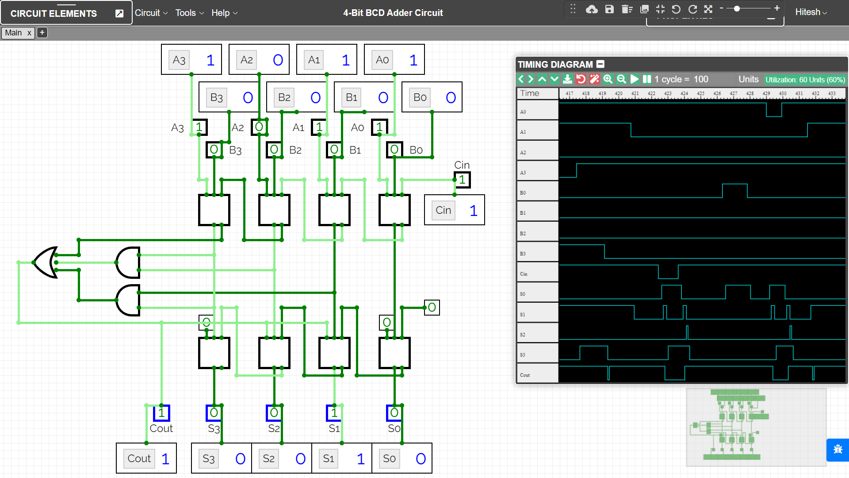

RESULT
The Working of 4-bit Binary Coded Decimal (BCD) Adder combinational circuit have been analysed and the Truth Table and Boolean Expression of BCD Adder using Full Adders and OR & AND gates have been studied and verified using the online simulator.

Criteria | Total Marks | Marks Obtained | Comments
Concept (A) | 2
Implementation (B) | 2
Performance (C) | 2
Total | 6

